Gingerbread Man  Our class story is The Gingerbread Man  Listen to a version of this story:  https://www.youtube.com/watch?v=H0uV6nWxO-w  Challenge:  Can you retell the story to an adult?  Can you draw your own story map for this story? You could change some of the characters or other things in the story.  Example of story map:  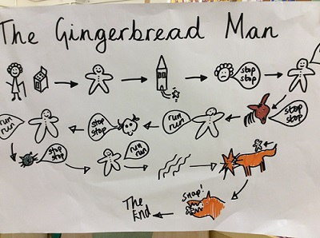  Extra: use your story map to write a story  (English) | Addition and subtraction  In Maths we are learning about adding and subtracting within 20 and then place value within 50  Practise doubling numbers to 20  Double 1 is 2  Double 2 is 4…  Add 2 numbers within 20 using adding on and subtract by counting back.  Practise number bonds within 20  Practise counting from 0 to 50 and backwards.  Practise writing number 21-50  How many tens?  How many ones?  (Maths) | Plants  Last half term we learnt lots about plants.  This half term we will be continuing to learn about plants  Draw and label the parts of a plant-  Stem  Leaves  Roots  Flower  Find some deciduous and evergreen trees when you go on a walk.  Draw a tree and label it-  Branches  Trunk  Leaves  Fruit  flowers  (Science)
This term the topic is:  Captivating Castles  The children will be learning about the history of Scarborough Castle.  Use this website to learn at least 3 facts about Scarborough Castle and then write these down.  https://kids.kiddle.co/Scarborough_Castle  (History) | Smoothies  Can you make a healthy smoothie or fruit kebab at home?  Draw it into your homework book and tell us what you have used or label your picture.  (DT) | Art- Printing  This half term we will be focussing on printing and learning about the artist Andy Warhol.  Challenge:  Use objects from home to create repeated patterns e.g. sponges, Lego, leaves, kitchen rolls....  Can you use primary colours?  Can you create any secondary colours?  Extra:  Make your own stamp to print with  Here are some ideas:  Lollypop sticks  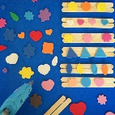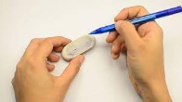  A rubber

